TITLE
Author 1
Author 2

Adress

Abstract: Maximum 50 words, English

Keywords: Maximum 5-7 words, English

1. Subtitle
Text

. (1)

. (2)
Equation
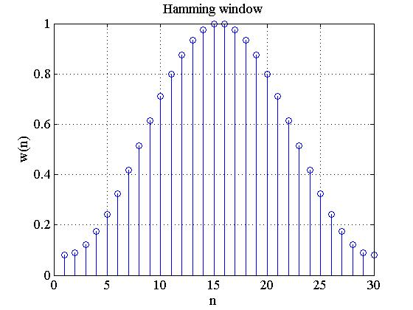
Figure 1. Short description
Table 1.
Short table description

REFERENCES
- Ortiz, Jr. S. Will PKI welcome a key to online security? – IEEE Computer, 2000, vol. 33, № 12, pp. 13-25.
- Cermak, Sh., Daunhauer, L. (1997) Sensory Processing in the Postinstitutional child. // The American Journal of Occupational Therapy,Vol. 51, 7, p. 500 – 507.
- Curry, J., Murphy, L. (1997) Comorbidity of anxiety disorders. In: March, J. ( Ed. ) Anxiety disorders in children and adolescents. New York, Guilford, p. 301 – 317.

